**ITI 200 Introduction to Cloud Computing**

**Bizi Fruit**

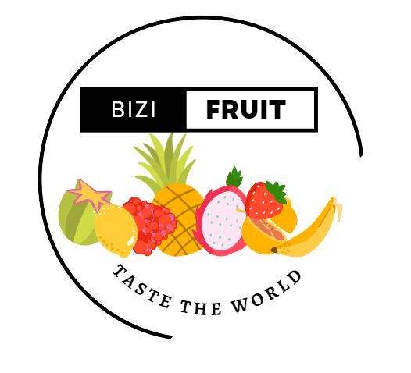

**Team Members**

Amanda Binu

Salvatore DiMaggio

# 1. Problem

* A lot of people in the United States do not have the time or money to explore the world and try fruits from different regions of the world.

# 2. Solution

* We have created a website to display our business of an exotic fruit shop that allows for online ordering all over the world.
* In the future we will have the online ordering system working but for now the website holds information about the business and products.
* Bizi Fruit ships unique fruit all over the world to the United States making it more accessible to enjoy good quality fruits of all varieties. Many of our fruits come from small organic farms to maintain the authenticity of the region's fruit. Other fruits are imported from countries or states with the best climates suitable for growing the fruit. We specialize in offering fruits that are not common in grocery stores and ship them directly to your door!

# 3. Demo

* <https://youtu.be/Uqkt2RWaLg4>

# 4. Lessons Learned

* <Divs> are very important for structuring
* How to incorporate a back end with a front of a website
* How to use bootstrap to create a friendly front end UI for the user
* How to use a server to hold data and send it to user by using get requests

# 5. Issues/Bugs Known

* Connecting the front end to backend
* We had to add cors because the priced would not display on the website from the back end
* Accidentally blended express js and vanilla node js together

# 6. Future Versions

* Bizi Fruit ships worldwide!
* Remove the show prices button and just have the prices change when things are added to the order
* Future version will have a page to order fruit online and not just a nonfunctional website

# 7. References

* Dr. Thiago Ferreira